

**2018 - Fall Update**

We have been BUSY – and glad to be back in action for 2017 & 2018 - what a FANTASTIC few years it has been!!!

In 2018 we paid out $10,792.01. Congratulations to all the owners and breeders – we hope you spent your money foolishly – on more horses – or breeding’s ☺ ***We certainly LOVED handing everyone those BIG cheques!!!***

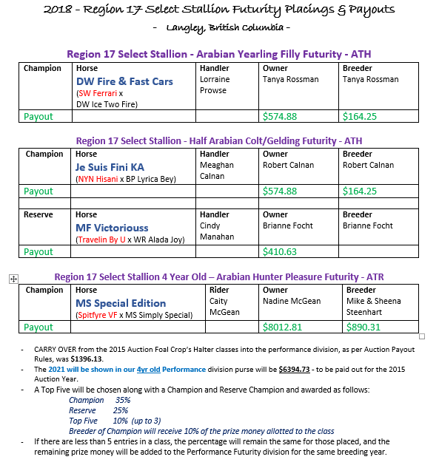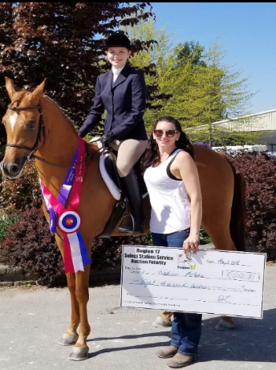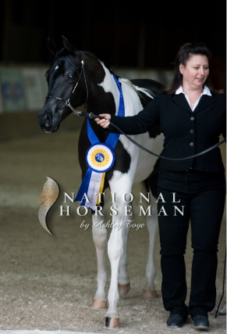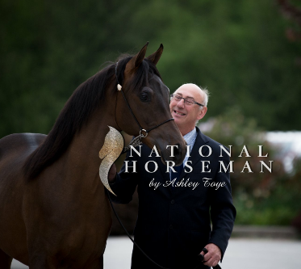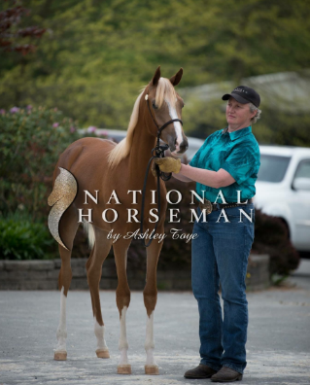This really is the BEST Payout Program in Canada

Check it out!!!

2018 Select Stallion Auction

LIVE BIDDING - RESULTS

* + 43 STALLIONS recruited
  + 22 BREEDINGS sold in the LIVE BIDDING portion of the Auction
  + Live Bidding total sales - $11,175.00

Still to come for the

2018 Select Stallion Auction:

Stallion Owner Buy Backs on any unsold breeding’s - Available NOW!!!

Minimum Bid purchases on unsold breeding’s – January 1 – Feb 28, 2019

2018 Auction Breeding’s - Mare Nominations – due by November 15, 2019

The above revenue will be added to & increase the Futurity $$ payable for the 2018 Auction!

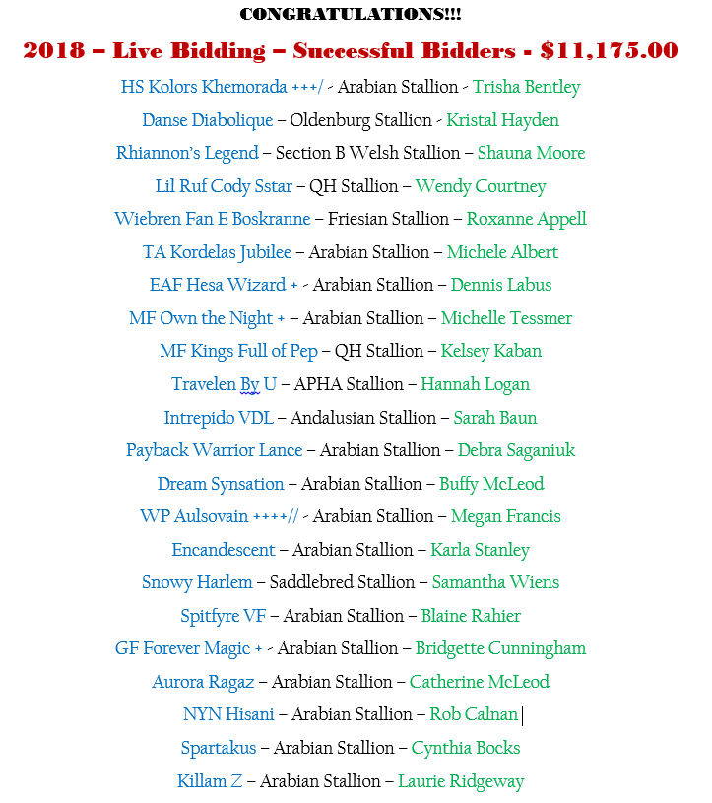

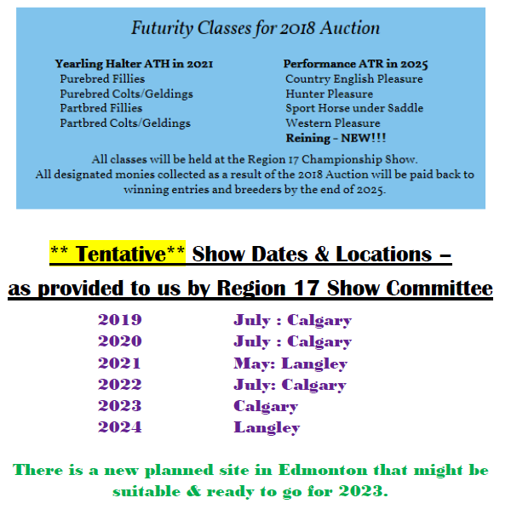

The SSAF Committee would like to extend a big THANK YOU to Renee Lupien, of Veracity Ventures, for not only designing and managing our website, but also for sharing her talent with our ADVERTISING DESIGNS.

Check out Renee’s website for all your design needs - <http://www.veracityv.com/>

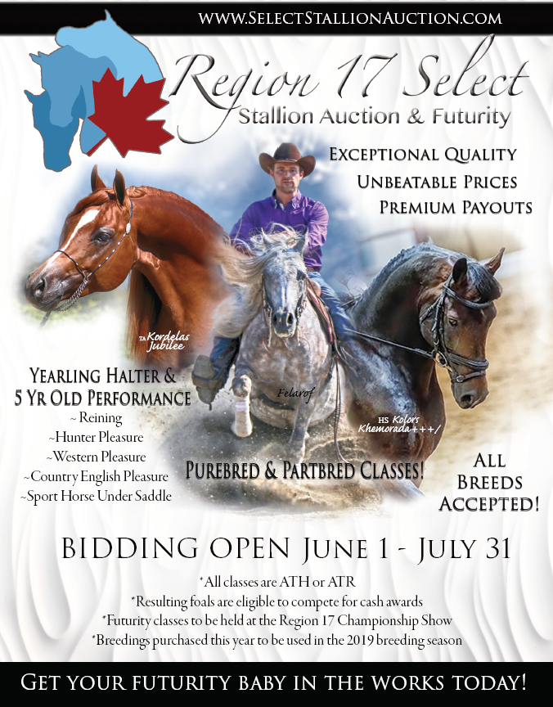 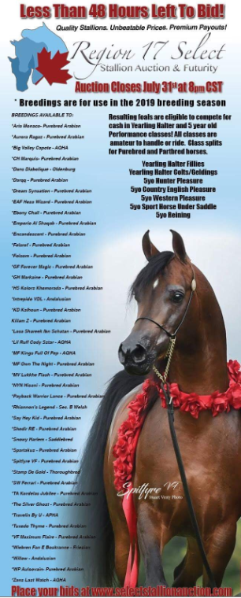 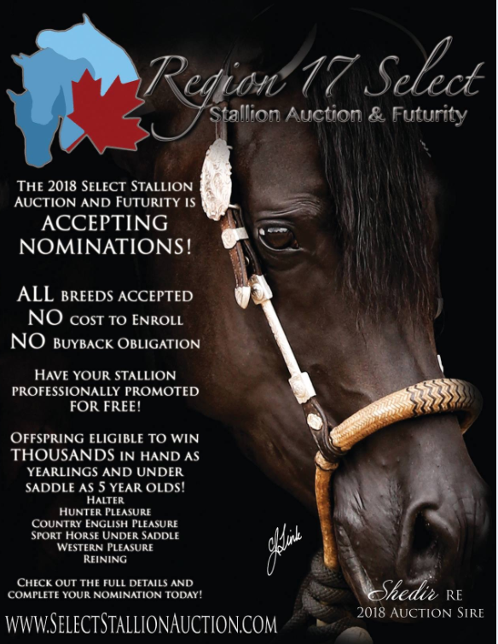

The Halter Futurity for the Yearlings born as a result of the 2015 Auction (born in 2017), and shown in 2018, had a total possible payout of $3285.00, at the Region 17 show in Langley, BC.

We paid out $1,888.88 to the (3) Halter horses that attended. The purse was divided among classes with entries - as per Auction rules. *As per program rules, if any of the classes have fewer than (5) entrants, the published percentage for each placing will remain the same, and the remaining prize money will be rolled over into to the Performance Futurity division for that year’s foal crop – in this case, the 2015 Auction, which will be payable in Performance Futurity in 2021.*

*Payouts rules can be found on our website* - <http://www.selectstallionauction.com/about>

Therefore, the Performance Futurity payout for these 2015 Auction Futurity Eligible foals – who will come back and show as 4yr olds in 2021 - will be $6394.73.

The Performance Futurity eligible horses that showed in 2018 at the Langley show as **4 Year Olds** (**born as a result of the 2012 Auction**) had a total purse of $8903.12, payable in 2018. **All of this money was paid out** to the **sole entrant** for a total of **$8,012.81 & the 10% to the breeder of the Champion $890.31**.

**WHATS NEW:**

Our NEW website is [www.selectstallionauction.com](http://www.selectstallionauction.com), or follow our Facebook page which has many updates.

We are pleased to have the following committee members who are working very hard, *if you wish to nominate your stallion for the 2019 Auction, or volunteer to work on this committee* – please contact us – we would love to see more representation – specifically from BC, Alberta & Manitoba – to join us on the SSAF Committee.

* Renee Lupien Email: [Renee@Veracityv.com](mailto:Renee@Veracityv.com) New website, promotions, and recruiting
* Tammy Hayward Email: [tamhayward@yahoo.com](mailto:tamhayward@yahoo.com) Coordinating and recruiting
* Christine White Email: [c.mclaren@hotmail.com](mailto:c.mclaren@hotmail.com) Recruiting

Important Information about the Auction & Futurity Classes:

* Breeding’s will continue to be sold for use in the following breeding season – 2018 Auction for breeding in 2019
  + Stallion Owner Buy Backs & Minimum Bid Purchase Period
* 2017 Auction – MARE NOMINATIONS – due by November 30, 2018. All mare owners have been notified.
* REINING classes for purebred & half Arabian have be added to the class list available to the 2017 Auction foals onwards
  + Reining has proven to be a fruitful addition - bringing in several new stallions to our program, all of which sold their breeding’s in the “live auction” for 2017 – the Reining stallions breeding’s totalled 39% of the live bid sold breeding’s, for a total of $4,550.00 (29%) of the TOTAL 2017 auction proceeds
* 2017 Auction wrapped up with a total sales of $15,879.85
  + The Auction proceeds for payouts resulting from the 2017 Auction will increase with the incoming Mare Nominations for these sold breeding’s – which are due in November 2018
* All Performance Futurity classes held **PRIOR** to 2024 shall continue to show as 4yr old (Amateur to Ride)
  + Western Pleasure, Hunter Pleasure, Country English Pleasure & Sport Horse Under Saddle
* 2017 Auction ONWARD – the Yearling Halter (Amateur to Handle) classes will be held in 2020 & the

**FIRST** of the ** NEW** **5 year old** Performance Futurity classes (Amateur to Ride) will be held in 2024.

* + Western Pleasure, Reining, Hunter Pleasure, Country English Pleasure & Sport Horse Under Saddle

**Select Stallion Auction Overall Summary**

|  |  |  |  |  |  |  |
| --- | --- | --- | --- | --- | --- | --- |
| **Auction Year** | **Nominated Stallions** | **Breeding’s Sold** | **Mares Nominated** | **Auction Fund** | **Halter Year** | **Performance Year** |
| 2009 | 36 | 20 | 18 | $ 18,110.00 | 2012 | 2015 |
| 2010 | 36 | 17 | 14 | $ 9,520.00 | 2013 | 2016 |
| 2011 | 32 | 20 | 17 | $ 13,650.00 | 2014 | 2017 |
| 2012 | 34 | 18 | 15 | $ 12,610.00 | 2015 | 2018  (4yr olds) |
| 2013 | 18 | 7 | 7 | $ 5,776.00 | 2016 | 2019  **$5742.36**  (4 year olds) |
| 2014 | 21 | 8 | 7 | $ 5,425.00 | 2017 | 2020  **$6596.10**  (4 year olds) |
| 2015 | 29 | 11 | 10 | $ 7,300.00 | 2018 | 2021  **$6394.73**  (4 year olds) |
| 2016 | 0 | 0 | 0 | $ - | N/A | N/A |
| 2017 | 57 | 34 | (mare nominations will be added to total Auction fund amount) | $15,879.85 | 2020 | 2024  *** 5yr olds *** |
| 2018 | 43 | 22 | (buy backs, minimum bid last chance, and mare nominations will be added to total Auction fund amount) | $11,175.00 | 2021 | 2025  *** 5yr olds *** |

* ***NOTE*** *- $1713.60 has been ADDED to Performance Years 2011 – 2015 Auctions as a Carry-over from 2010 - no entries\**

**2016 Auction - Yearling Halter Division**

There was **NOT** a SSAF Auction held in 2016 so there will **NOT** be any YEARLING FUTURITY HALTER CLASSES held in 2019

**2013 Select Stallion Auction - 4 Year Old Performance Division**

**Eligible to show in 2019 @ R17 Show in Calgary, AB - for a total payout of $5742.36**

|  |  |  |  |  |
| --- | --- | --- | --- | --- |
| **Horse Name** | **Sire** | **Dam** | **Owner** | **Purebred/ Part-bred** |
| ES Liberty Belle | Apaladin ++ | Lipstick N Dynamite | Nicole Muller | Part-bred |
| Beans Make Me Tango | DTD Jess Dancin ++/ | HH Khlassy Last Legacy | Tamara Taylor | Part-bred |
| MV Hey Hot Jewel | Say Hey Kid +++/ | MV Polish Amber | Candace Oakes | Purebred |
| Alallujah HPA | Say Hey Kid +++/ | VS Aladdinns Allanna | Debbie Bartelen | Purebred |

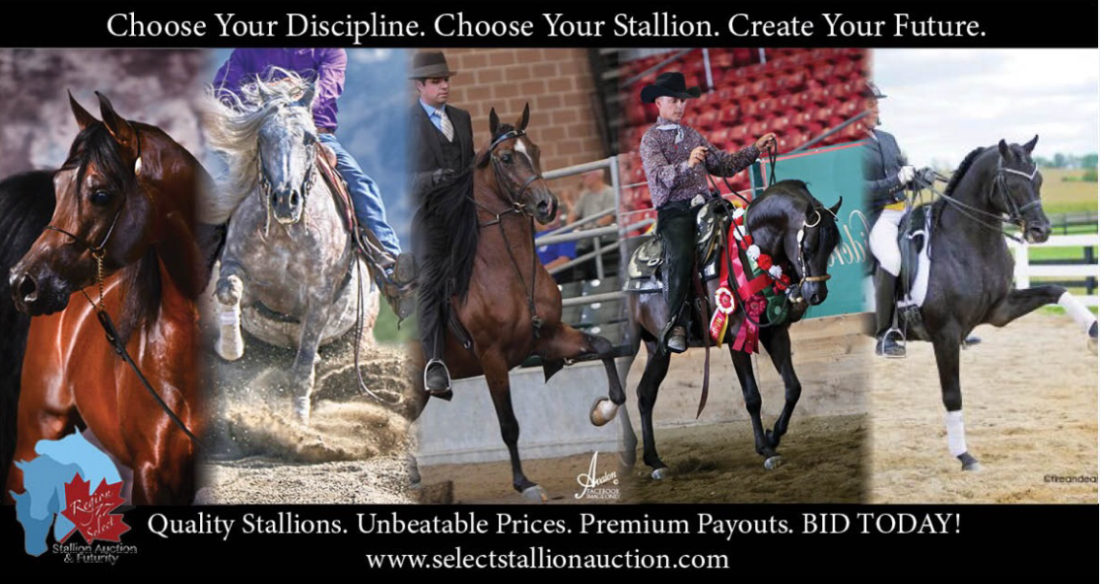

**2017 Auction - Mare Nominations – due by November 15, 2018**

