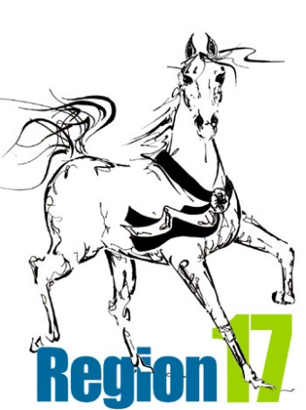

REGION 17 YOUTH BURSARY AWARD APPLICATION FORM
NAME:__________________________________________________________________________
ADDRESS:________________________________________________________________________
CITY/PROVINCE:___________________________________________________________________
TELEPHONE:____________________________POSTAL CODE:______________________________
EMAIL:_________________________________GRADUATION YEAR:_________________________
REGION 17 CLUB/ASSOCIATION:______________________________________________________
AHA MEMBERSHIP NUMBER:_______________DATE OF BIRTH:_____________________________
THE FOLLOWING DOCUMENTATION MUST BE PROVIDED, TO THE REGION 17 YOUTH BURSARY COORDINATOR, BY THE RECIPIENT(S) OF THIS BURSARY PRIOR TO DISBURSEMENT OF THE BURSARY FUNDS:
- PROOF OF GRADUATION FROM HIGH SCHOOL AND PROOF OF ACCEPTANCE AT AN ACCREDITED INSTITUTION FOR HIGHER LEARNING. (IF THE BURSARY RECIPIENT(S) HAS NOT YET GRADUATED FROM HIGH SCHOOL, THE BURSARY MONIES WILL BE HELD IN TRUST UNTIL SUCH TIME AS PROOF OF GRADUATION FROM HIGH SCHOOL AND PROOF OF ACCEPTANCE, AT AN ACCREDITED INSTITUTION FOR HIGHER LEARNING, IS RECEIVED).
- THE NAME, MAILING ADDRESS, STUDENT NUMBER/ID AND ANY OTHER PERTINENT INFORMATION RELATING TO THE INSTITUTION FOR HIGHER LEARNING AT WHICH THE RECIPIENT HAS BEEN ACCEPTED. BURSARY FUNDS WILL BE FORWARDED DIRECTLY TO THE ACCREDITED INSTITUTION LISTED BY THE BURSARY RECIPIENT(S).
- BURSARY FUNDS MAY BE PAID DIRECTLY TO THE BURSARY RECIPIENT(S) ONLY UPON PROOF OF PAID TUITION OR COSTS INCIDENTAL TO ATTENDANCE AT SUCH INSTITUTION EQUAL TO BUT NOT IN EXCESS OF THAT PORTION OF THE BURSARY TO WHICH THE RECIPIENT IS ENTITLED. DETERMINATION OF APPROPRIATE COSTS INCIDENTAL TO ATTENDANCE WILL BE AT THE SOLE DISCRETION, EXERCISED REASONABLY, OF THE BURSARY COORDINATOR.
ANY YOUTH MEMBER OF REGION 17 MAY APPLY FOR THIS BURSARY. SUBMISSION OF THE APPLICATION CONSTITUTES ACCEPTANCE OF THE TERMS AND CONDITIONS OF THE APPLICATION REQUIREMENTS AND THE AWARD APPLICATION FORM.
Please note that all bursary funds must be claimed prior to the twenty-first (21st) birthday of the bursary award recipient(s). The name of the award recipient will be announced at the Region 17 Championship Show and will be posted on the Region 17 website. Direct any questions and/or submit this application and supporting documents, in triplicate, to the Region 17 Bursary Chairperson as indicated on the Application Requirements form.
APPLICANT SIGNATURE:_____________________________________________________________
PARENT SIGNATURE:________________________________________________________________

