OKAY.. now that I have your attention…(who could resist this little guy!)
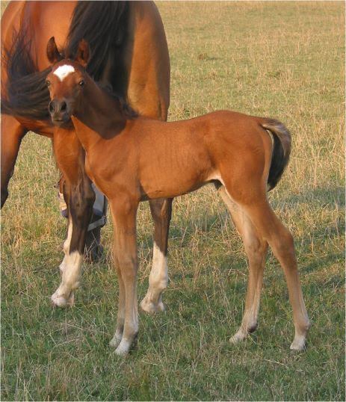
The Local Level Involvement Task Force has re-introduced and updated the Discovery Farm concept, developed a FaceBook page to promote our horse, introduced the Arabian Badge Program, developed a Marketing Toolkit and the Meet an Arabian Horse Day Toolkit for both virtual and (hopefully not too distant) personal meet and greets and a number of other means to involve young and “mature” with the Arabian and Half-Arabian horse!
We are excited that the Local Level Involvement Task Force has just been approved as a Standing Committee of AHA with the cornerstones of Breed Growth, and Communication.
Each Region is encouraged to have 2 representatives on the committee, but they must be appointed to the Committee. Involvement requires only attendance at the virtual meetings and assisting with one activity. Region 17 needs another member!
Let your Director or Vice-Director know as soon as possible if you are interested. Be part of something great moving interest in the Arabian and Half-Arabian forward!

